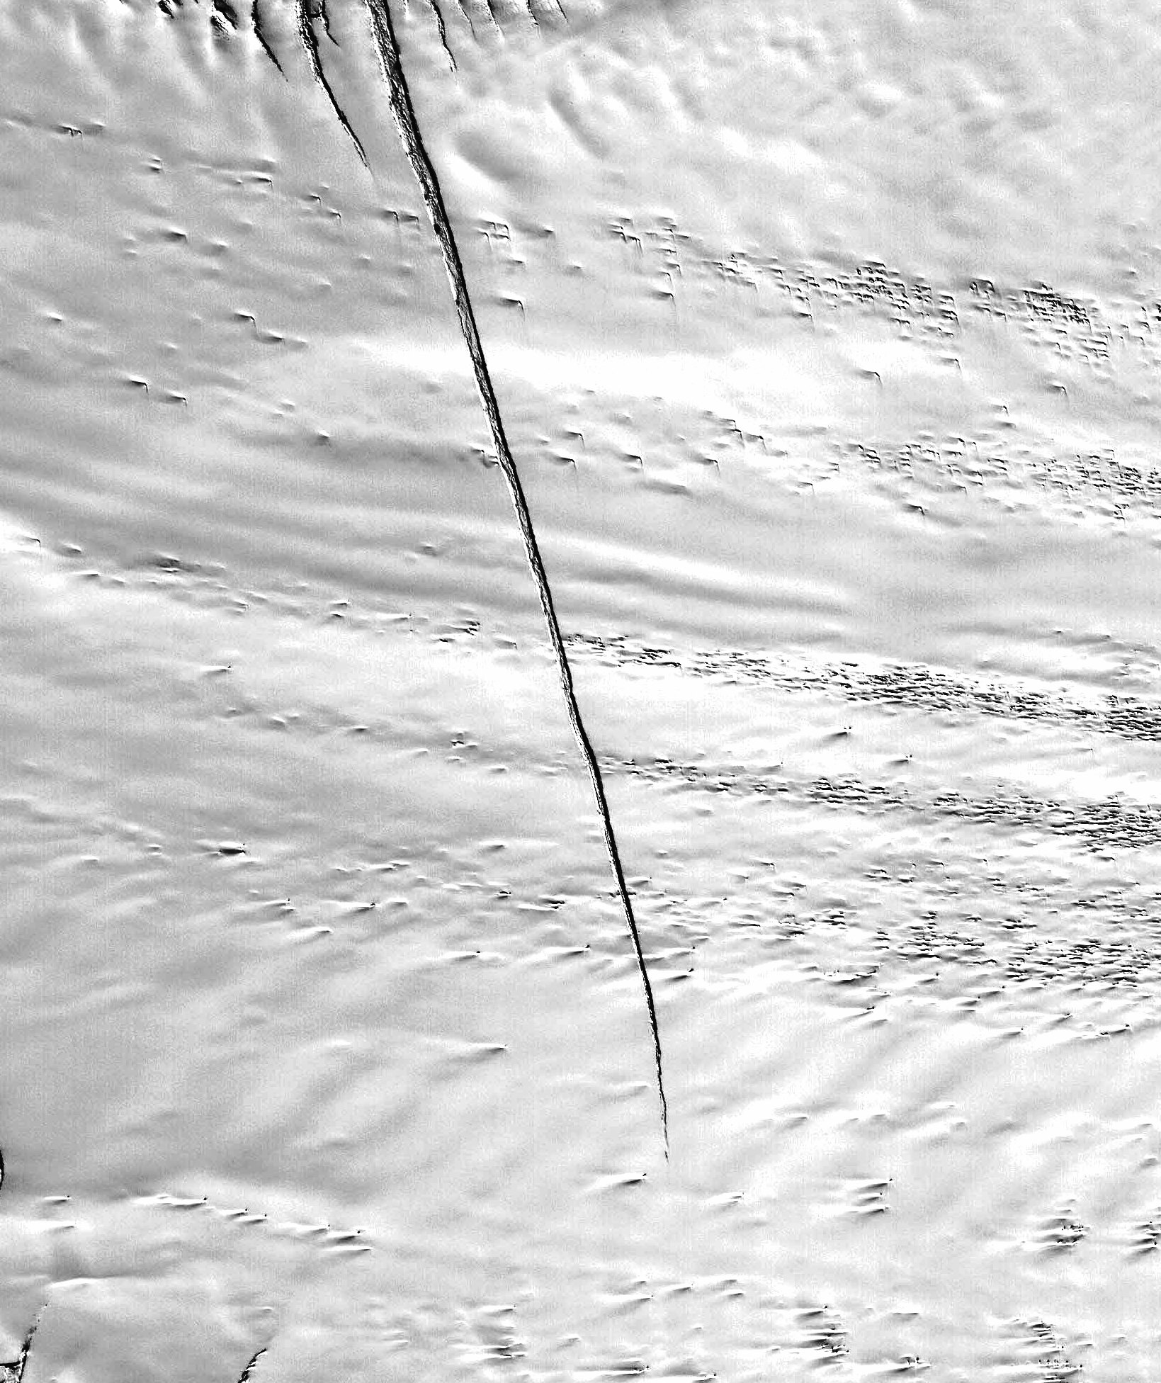



U.S. AIR FORCE
LC-130 Deep Field Workshop
Conference Report
May 7 & 8, 2007
Arlington, VA

Table of Contents

Executive Summary …………………………………….……. 2

1 Introduction and Motivation ………………………….…… 3

2 LC-130 Deep Field Workshop Objectives ………………… 4
2.1 Site Imagery ………………………………… 4
2.2 Risk Assessment and Resource Allocation ... 5
2.3 Improving Process and Planning Groups … 5
2.4 Communications and Feedback …………… 6

3 The Way Forward …………………………………………. 7

4 Conclusion ………………………………………………….. 8

Notes …………………………………………………………... 9

Appendices
A Workshop Agenda …………………………………. 10
B Workshop Attendees ……………………………….. 12
C Relevant Web Links ………………………………... 13
D Schematic of Planning Process ……………………. 14

Cover image: ASTER image of the Pine Island glacier, Antarctica. Courtesy of NASA Goddard Space Flight Center. Available at: http://asterweb.jpl.nasa.gov/gallery-detail.asp?name=PIG
Executive Summary

Since 1998, LC-130 support for deep field camps has waned. As a result, there has been some loss of expertise in operating in deep-field locations; and the planning process for analyzing future deep-field sites has lost some flexibility. Additionally, some of the resources for obtaining radar imagery may not be available beyond 2007. Two major events, however, will soon relieve a large number of required LC-130 flights to the South Pole. South Pole Station Modernization efforts are nearly complete, and the South Pole Surface Traverse will soon begin delivering large amounts of cargo and fuel to the Pole. Thus, the LC-130s will have the opportunity to greatly increase their support deep-field camps.

As a result, the National Science Foundation Office of Polar Programs sponsored a workshop to address the issue of planning and executing deep-field missions with LC-130s. Workshop attendees identified available sources of imagery and developed planning and execution processes. The process begins with a standing committee incorporating imagery and applying knowledge of glaciology to predict the likelihood of hazards. The recommendations of the committee then follow through a pre-season planning process of engaging all parties concerned in the success of deep-field camp support. The 109th Airlift Wing will initiate aircrew training programs to fully restore their deep-field capabilities. These process changes will be in place for the 2007-2008 Operation Deep Freeze season.

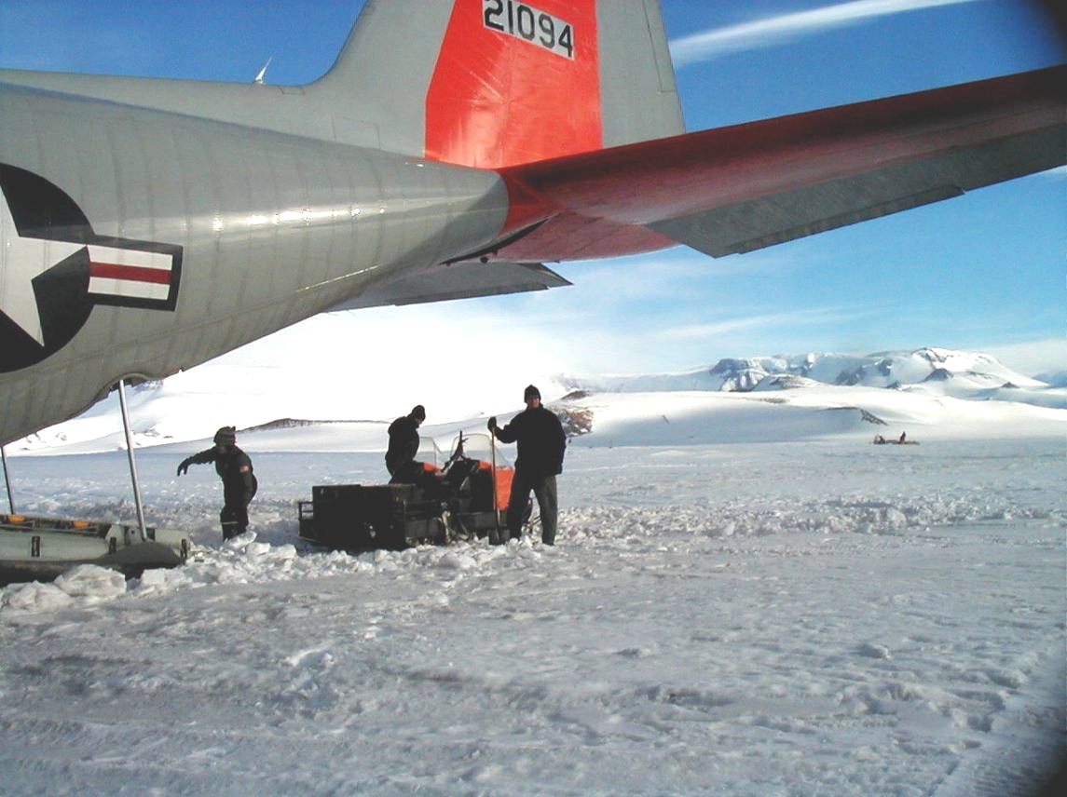

LC-130 on the snow at Beardmore South, Antarctica, January, 2003.
Courtesy of Lt Col Mark Doll
1. Introduction & Motivation

In 2004, National Science Foundation Office of Polar Programs Polar Research Support Section (NSF OPP PRSS) Committee of Visitors (COV) made a recommendation to define the capabilities of the 109th Airlift Wing (AW) and the LC-130¹. In particular, the committee questioned the 109th AW’s ability to operate in open-field sites and the protocol for planning such operations.

The NSF also sponsored a workshop to define the requirement for a Long-range Aircraft for Research in Antarctica (LARA). The LARA report concluded that “if only a single long-range research aircraft were available, an LC-130 could accomplish the broadest spectrum of scientific goals identified at the workshop.”²

For over 40 years, the United States Antarctic Program relied on the LC-130 for much of the logistical support to Antarctic field camps. The LC-130, by virtue of being the largest ski-equipped aircraft in the world, is a valuable asset to the program. The cargo-carrying capacity, speed, range and endurance of the LC-130 make it uniquely suited to support remote, open-field camps in Antarctica. A series of events, however, altered the role of the LC-130 in Antarctica.

In 1998, an 109th Airlift Wing (AW) LC-130 encountered a crevasse upon landing at a new open-snow site in west Antarctica. This forced a rigid approach to pre-season planning for LC-130 open-field landing sites.VXE-6, the US Navy’s LC-130 squadron, was decommissioned in 1999, which further removed some flexibility in executing open-field missions. Finally, South Pole Station modernization diverted the majority of LC-130 missions to the South Pole. This had the effect of limiting aircrew exposure to open-field sites, thereby limiting aircrew experience in these operations.

Two significant events are forcing the reversal of this trend. South Pole Station modernization is nearly complete, and the South Pole surface traverse is scheduled to become fully operational in 2009. This will relieve approximately 100 LC-130 flights to the Pole each season, thereby allowing more deep-field operations. This will require the 109th AW to train and prepare additional aircrews for open-field landings. Additionally, some of the resources the 109th AW uses for their pre-season planning may not be available in the near future. Conversely, there are some new sources available that may be equal to, or better, than the existing sources.

There are some potential improvements that promise to greatly increase the capabilities of the LC-130. The 8-bladed NP2000 propeller and new jet-assisted take-off rockets are expected to increase take-off ability. The most prominent improvement, however, is the MiniSAR Crevasse Detection Radar. The intent for the radar is to allow an LC-130 to fly over an open-field site and search for crevasses in real time. All of these systems are in the early stages of operational testing and none are guaranteed to be fielded. Thus, they are not yet considered viable options. The Air National Guard is, nevertheless, firmly committed to supporting these initiatives.

In light of changing deep-field goals and emerging technology, the NSF recently sponsored a workshop (May 2007) to gather experts from various fields to investigate streamlining planning process methods as well as increasing LC-130 accessibility for open-field landing sites.

2. LC-130 Deep-Field Workshop Objectives

The overall objective of the May 2007 NSF Workshop was to review the current processes by which new open-field landing sites are planned and executed. The vision is to incorporate new technologies with a prudent approach to planning. All aspects of the process were reviewed to include integration in the science proposal process through completion of the LC-130 flights.

The workshop convened at the Holiday Inn, Arlington VA, on May 7th & 8th 2007. The group was comprised of 22 individuals who represent the NSF Antarctic Sciences and the Antarctic Infrastructure & Logistics Divisions, 109th AW NSF OPP COV, Raytheon Polar Services Corporation (RPSC) and scientists with expertise in remote sensing of snow. A list of workshop attendees is provided in Appendix B.

The specific objectives of the workshop were to: (1) Investigate options for site imagery; (2) outline factors for risk assessment & resource allocation; (3) develop processes to improve site assessment and construct planning groups; and (4) improve communications & feedback between the 109th AW, RPSC & the Principle Investigators.

The agenda (Appendix A) was structured around these four objectives. Time was allocated for subject matter experts to present relevant material in each objective, followed by discussions on how to best meet each objective. The results of each objective were then carried forward and incorporated into the overall vision.

2.1 Site Imagery

The current process of acquiring imagery involves space-borne synthetic aperture radar (SAR). However successful this has been, there are limitations to the ability to detect features in snow. Additionally, there will be some difficulty in accessing this technology in the future, forcing a search for other possibilities. A number of options were presented including radar and electro-optical (EO) imaging systems. The technical merits of each system are beyond the scope of this report; a list of suggested readings and web links is available in Appendix C.

Since the phenomenon of radar’s interaction with snow and ice is not entirely understood, relying solely on radar is not without risk. The consensus of the group is that a combination of radar and EO images, combined with knowledge of glaciology, was the most sensible approach. The work of Dr Bindschadler for the South Pole Traverse exemplifies the advantage of using complimentary systems³. In addition, the Site Review Committee (SRC - described below) will cull GIS databases to obtain any pertinent information on past operations in nearby areas.

The three primary hazards in a landing site are crevasses, large sastrugi and the stability (hardness or softness) of the snow. Given the resources above, it is expected that an expert could make a sound and reliable conclusion about the snow. Although individual crevasses may not be clear from an image, it may show the likelihood of their presence. Secondary hazards, such as slope and surrounding terrain should be relatively easy to discern from the images.

2.2 Risk Assessment and Resource Allocation

Risk is inherent in any open-field landing. It is everyone’s responsibility to manage and mitigate the risk at safe and acceptable levels. Not all sites present the same hazards. Crevassing, local weather, terrain, snow conditions all require consideration.

If a site is expected to be relatively benign, a LC-130 will be able to, along with camp personnel, fly over and make the initial landing. On the other hand, there may be reasons to send a Twin Otter in advance of the LC-130. If crevasses are known or suspected, such as camps on icestreams, it may be wise to send the ground penetrating radar. Another possible scenario would be to send a skiway groomer and a representative from the 109th AW to prepare the area so the LC-130 can carry more cargo on the initial flights. Typical weather patterns may also influence the decision to allocate a Twin Otter. If high terrain and/or poor weather pose obstacles, sending a Twin Otter with a weather observer may preclude long delays in establishing the camp.

The 109th AW, in conjunction with the Deputy Commander Support Forces Antarctica, will incorporate existing Air Force risk management tools in their pre-season planning. This generally ranks expected hazards on a scale varying from low to extreme. The level of hazards is then compared with mitigating measures to ensure the overall level of risk is acceptable.

2.3 Improving Site Assessment Process and Construct of Planning Groups

It is vital that the assessment of potential LC-130 landing sites occur in a timely manner. Ideally, the process should fit within the normal flow of reviewing science proposals. Nonetheless, the lead time for gathering imagery may take several months. Therefore, a timeline was developed which will provide enough time to order and analyze imagery. A description of the proposed timeline follows (a detailed flowchart appears in Appendix D).

In early October, the NSF will forward selected site for consideration to the SRC. The SRC is a standing committee of scientists with experience in remote sensing of snow, glaciology, and/or extensive experience in polar regions. The NSF OPP Antarctic Sciences Division (ANT) will select the members of the committee on a yearly basis. It is recognized that there may be a conflict of interests with members of the SRC and certain proposed landing sites; therefore ART will address this on a case-by-case basis. Members of the SRC will collaborate to obtain imagery on the proposed landing sites. The SRC will also obtain climatological data from SPAWAR Weather.

The SRC will meet to make their initial determination of the likelihood of hazards and the level of risk and report back to ANT by December 1st. A NSF-DoD Liaison will be present when the SRC holds their meetings. If the SRC is satisfied with the quality of the analysis and the level of risk, their recommendation will stand until the next meeting. If the SRC deems it necessary to obtain more information on a site, they may request a fly-over.

Requests for a fly-over will be sent to the senior NSF Representative in McMurdo who will then task RPSC to coordinate the flight. The fly-over may be carried out during a routine flight and may be accomplished by any flying asset. The 109th AW Deployed Commander will meet with the pilots and ensure the quality of information is satisfactory. The NSF Representative will then direct the information back to ANT and the SRC.

The Put-in Plan Development meeting will occur in March or April and include representatives from the SRC, NSF, 109th AW, NSF-DoD liaisons and RPSC. This is the opportunity for the SRC to detail their findings. The rest of the members have the chance listen and examine the information. This is also where the initial planning for the coming season begins. Members may make recommendations to include other resources such as Twin Otter support, weather observers or skiway groomers.

By June 1st, ANT will forward sites associated with proposals that have been awarded grants to the 109th AW. The 109th will then begin detailed landing site planning. This planning includes calculating fuel & cargo loads, length of crew day.

In September, members from the NSF, RPSC, SPAWAR WX and the Principal Investigators (PI) meet at the 109th AW in Schenectady, NY. This provides the PI an opportunity to meet the flight crews expected to fly their missions. They, in turn, can brief their goals and particular concerns. This meeting will normally coincide with the 109th’s customary pre-season meeting. As has occurred in the past, all parties in place at McMurdo meet before the actual deep-field flight to ensure all final details are coordinated.

2.4 Communications and Feedback

The process is designed to ensure that participants come together at the appropriate time to confirm that every one knows the plan. Finally, a process to provide feedback was developed. The 109th AW will ensure they take pictures after landing at a new site. These pictures will then go to the SRC for use in validating their work. RPSC and NSF will include the 109th AW in the feedback process after open-field camp personnel return to McMurdo.

3. The Way Forward

The conference identified the initial starting point from which to begin the above-mentioned processes. To ensure the goals of the workshop gain momentum, a number of necessary action items were assigned:

- The first SRC, comprised of Drs. Bindschadler, Hamilton & Scambos, will begin collaborating on two proposed sited for the 2007-08 Antarctic season: Shackleton Glacier and the ITASE winter-over site. The 109th will send historical data on past Shackleton flights to the SRC. The SRC will present their analysis at the WAIS Research Workshop meeting in September 2007. A member of the 109th AW will be present and will brief the results of this workshop to the WAIS Research group.

- The 109th AW will host a glaciologist to teach a so-called “Glaciology 101” class to the flight crews in September.

- The 109th AW will develop a training program to emphasize open-field operations. This will include visual recognition of snow surface features, open-snow take-offs and landings.

- The 109th AW will make plans to include a third pilot who is highly experienced in open-field put-ins. This pilot will serve as an instructor and safety observer, as well as a means of continuity between different crews. The third-pilot is the principal contact with PIs and will be onboard for the initial put-in.

- The 109th AW will develop and implement a system to take photographs during initial put-in flights. These pictures will be documented, included in the historical data, and forwarded to the SRC.

- NSF OPP ANT will implement a GIS database to compile the various records and files kept by different agencies. The 109th AW will make their records available upon request.

4. Conclusion

The results of the workshop set the strategy for the future use of LC-130s in support of deep-field locations. This is not to say this will be a static process; rather, it should continue to evolve as new methods, ideas and technologies are brought forward. New satellites may offer images with more detail. Members of the SRC may change in response to the needed expertise. The MiniSAR Crevasse Detection Radar may radically alter the planning process. Finally, lessons learned from prior years may alter the risk assessment model.

In spite of possible changes, the process should never stray from its original intent: to preserve the flexibility of using the LC-130 in the deep field and to safely manage the risks involved in conducting these operations.

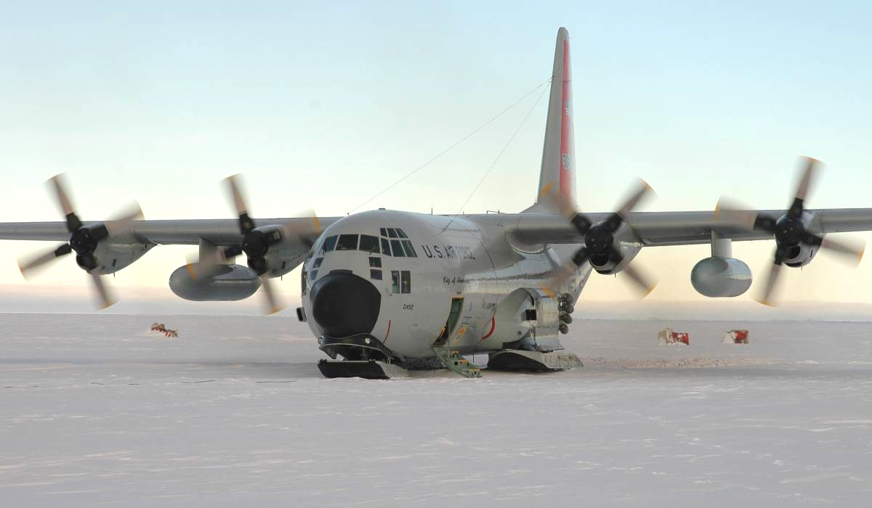

LC-130 on the snow after first landing at Pine Island, Antarctica, November 18, 2004. Courtesy Lt Col Mark Doll
Notes

- Report of Workshop Held September 27-29, 2004. Scientific Opportunities for a Long-Range Aircraft for Research in Antarctica, July 2005, pg 37. Available at: http://polarmet.mps.ohio-state.edu/lara/doc/LARA_July_2005.pdf

- Report of National Science Foundation Office of Polar Programs Polar Research Support Section Committee of Visitors, 2004, pg 11. Available at: http://www.nsf.gov/od/opp/gpra/cov_prss_2004.pdf

- Bindschadler, R., Vornberger, P., 2005. Guiding the South Pole Traverse with ASTER Imagery, Journal of Glaciology, Vol. 51, No. 172, pg. 179-180.

Appendix A

LC-130 Deep-Field Landing Sites
Working Group

Location: Holiday Inn Arlington, 4610N Fairfax Drive, Arlington VA, 22203
Wilson Room. Ground Floor
Agenda

Monday, 7 May, 2007

0800-0815 Opening remarks [Chiang, Borg, German]

0815-0830 Introductions of Attendees

0830-0900 LC-130 Operations [Doll]
- Capabilities & Limitations
- Aircrew Training
- Critical Information & Risk Analysis
- Future Capabilities

0900-1230 Use of Remote Sensing for Site Selection
0900 Fiedler (History and current process)
0925 Bindschadler (LandSat and ASTER, South Pole Traverse Route)
0950 Scambos (MoA, Remote sensing of snow)
1015 Break
1040 Hamilton (Glaciological Constraints)
1105 Archer (RPSC capabilities)
1130 Summary & discussion

1230-1330 Lunch

1330-1430 Discussion of options to improve imagery assessment

1430-1500 Science Proposal & Site Selection Process [RPSC Grundberg]
PI-109th-RPSC interface

  - Break

1515-1545 Field Support Issues [RPSC Johnson]

1545-1615 Regional Weather & Forecasting Ability [SPAWARS Clogston]

1615-1700 Discussion of options to improve:
-site requirements
-risk assessment
Tuesday 8 May, 2007

0830-0850 Review & Lead-in [Doll]

0850-0915 Post-season Feedback from PIs [Doll, Grundberg]

0915-0945 Construct of Planning Groups [Doll]
- Image Interpretation Group
- Pre-season Planning Group
- McMurdo Execution Group

0945-1000 Break

1000-1100 Final discussion of new process

1100-1200 Recap and Review of Action Items [Doll]
Appendix B

 | LC-130 Deep Field Working Group Attendees
 | Name |  | Agency | Email | Phone
Mr. | Erick | Chiang | NSF – Director AI&L | echiang@nsf.gov | 703-292-7437
Dr. | Scott | Borg | NSF – Antarctic Sciences Division | sborg@nsf.gov | 703-292-7412
Dr. | Thomas | Wagner | NSF – Antarctic Geology & Geophysics | twagner@nsf.gov | 703-292-4746
Dr. | Julie | Palais | NSF – Antarctic Glaciology | jpalais@nsf.gov | 703-292-7419
Mr. | Brian | Stone | NSF – Deputy AI&L | bstone@nsf.gov | 703-292-7458
Mr. | Dave | Bresnahan | NSF – AI&L System Ops | dbresnah@nsf.gov | 703-292-7441
Mr. | George | Blaisdell | NSF – Operations Manager | gblaisde@nsf.gov | 703-292-7447
Dr. | Nelia | Dunbar | COV, New Mexico Tech | nelia@nmt.edu | 505-835-5783
Dr. | Ralph | Fiedler | NRL | fiedler@nrl.navy.mil | 202-767-0644
Dr. | Mark | Sletten | NRL | msletten@ccs.nrl.navy.mil | 202-404-7971
Dr. | Gordon | Hamilton | U of Maine, Orono – Climate Change Inst | gordon.hamilton@maine.edu | 207-581-3446
Dr. | Ted | Scambos | NSIDC | teds@kryos.colorado.edu | 303-492-1113
Dr. | Robert | Bindschadler | NASA Goddard Hydrospheric and Biospheric Sci Lab | Robert.A.Bindschadler@nasa.gov | 301-614-5707
Col | Paul | Sheppard | DoD Liaison – NSF | psheppar@nsf.gov | 703-292-7454
Lt Col | Ian | Biggins | USAF Liaison – NSF | ibiggins@nsf.gov | 703-292-7449
Lt Col | Mark | Doll | 139AS/DOP | mdoll@nsf.gov , mark.doll@nyscot.ang.af.mil | 703-292-7477
Col | Tony | German | 109AW/CC | anthony.german@nyscot.ang.af.mil | 518-344-2430
Lt Col | Gary | James | 109OG/CC | gary.james@nyscot.ang.af.mil | 518-344-2422
Ms. | Julie | Grundberg | RPSC-Fixed Wing | jgrundie@yahoo.com | 773-573-2029
Mr. | Brian | Johnson | RPSC-Field Camp Support | Brian.Johnson@usap.gov | 800-688-8606, x 32449
Mr | Chester | Clogston | SPAWAR Weather | chester.clogston@navy.mil | 843-218-5271
Mr | Andy | Archer | RPSC | andy.archer@usap.gov

Appendix C

Relevant web links

Reference Material

National Science Foundation Office of Polar Programs Committee of Visitors
2004 report. http://www.nsf.gov/od/opp/gpra/cov_prss_2004.pdf

Article on use of ASTER imagery for South Pole Traverse
http://earthobservatory.nasa.gov/Study/Crevasse/crevasse4.html

Long-Range Aircraft for Research in Antarctica main page
http://polarmet.mps.ohio-state.edu/lara/

Space-born imagine systems

ASTER – Advanced Spaceborne Thermal Emission and Reflection Radiometer
http://asterweb.jpl.nasa.gov/index.asp

MODIS – Moderate Resolution Imaging Spectroradiometer
http://nsidc.org/daac/modis/index.html

Multi-angle Imaging Spectroradiometer
http://www-misr.jpl.nasa.gov/

QuickBird
http://www.digitalglobe.com/index.php

IKONOS
http://www.geoeye.com/products/imagery/ikonos/default.htm

RADARSAT-2
http://www.radarsat2.info/

Mosaic maps of Antarctica

MoA - Mosaic of Antarctica
http://earthobservatory.nasa.gov/Study/MOA/

LIMA - Landsat Image Mosaic of Antarctica
http://lima.usgs.gov/

Appendix D

Schematic of Planning Process
NSF selects site for consideration and forwards to SRC
SPAWAR Weather Input
SRC makes initial determination on the suitability of the site

Does it require fly-over?
Arrange for fly-over in Jan or Feb
Put-in Plan Development meeting
[SRC, 109th AW, NSF, RPSC, DoD Liaison]
Pre-season Planning meets at 109th AW [PI, 109th AW]

McMurdo Planning Group meets before flight to finalize details
[NSF, PI, SFA, 109th AW, RPSC, SPAWAR Wx]

Put-in Flight

Feedback session when Field Party returns to McMurdo
[NSF, PI, SFA, 109th AW, RPSC, SPAWAR Wx]
Oct
Dec
Mar-Apr
Sep
Nov-Dec
Nov-Dec
Dec-Feb
No
Yes

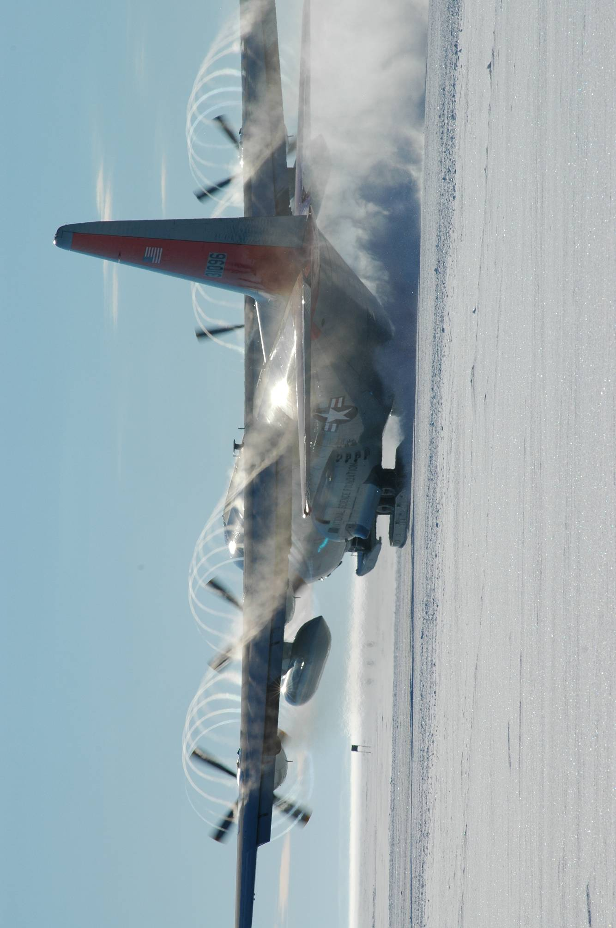
Mark Doll

