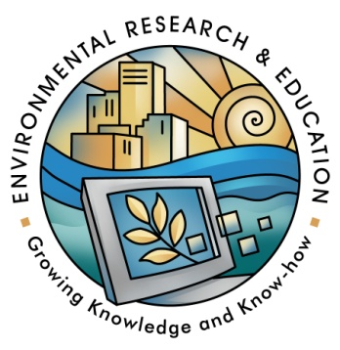
Advisory Committee for Environmental Research and Education (AC ERE)
NSF Room 1235, 4201 Wilson Boulevard, Arlington, VA 22230
Agenda – Day 1

Wednesday, September 16, 2015

8:30 – 9:00 AM Light Refreshments
9:00 – 9:30 AM Welcoming remarks Dr. David Skole (Chair, AC ERE) NSF Updates Dr. James Olds (AD BIO)

9:30 - 10:30 AM Presentation and discussion of the Gold Report

10:30 – 10:45 BREAK (15 Min)

10:45 – 11:00 Other committee business - Approval of the previous minutes, discussion of the meeting agenda

11:00 – 12:00 PM Presentation on NAS Geoengineering Climate study: Dr. Ken Caldeira, Carnegie Institution

12:00 – 1:00 PM Lunch

1:00 – 2:00 PM a.) NEON - National Ecological Observatory Network. PO: Dr. Liz Blood
b.) CRISP - Critical Resilient Interdependent Infrastructure Systems and Processes. PO: Dr. Elise Miller-Hooks

2:00 – 2:45 PM Preparation for meeting with the ADs

2:45 – 3:00 PM BREAK (15 Min)

3:00 – 4:00 PM Presentation of the Gold Report to the NSF ADs

4:00 - 5:00 PM Presentation on CEOSE activities: Dr. Alicia Knoedler, University of Oklahoma
Discussion of broadening participation

Advisory Committee for Environmental Research and Education (AC ERE)
NSF Room 1235, 4201 Wilson Boulevard, Arlington, VA 22230
Agenda – Day 2

Thursday, September 17, 2015
8:30 – 9:00 AM Light Refreshments
9:00 – 10:00 AM Discussion of Gold Report follow-up activities

10:00 - 11:00 AM Discussion of emerging issues in environmental design: Geoengineering and synthetic biology

11:00 – 12:00 PM a.) SEES Assessment/Evaluation status. Staff Associate: Beth Zelenski
b.) PREEVents – Prediction of and Resilience against Extreme Events. PO:
Dr. Therese Moretto Jorgensen
c.) INFEWS – Innovations at the Nexus of Food, Energy, and Water. PO: Dr. Tom Torgersen & DD: Dr. JoAnn Lighty

12:00 – 1:00 PM Working Lunch
Discussion of Chair's Letter to the Director
Concluding discussion, recommendations for committee members,
and meeting wrap-up

Set Next meeting: March___, 2016
1:00 PM Meeting Adjourned

Join WebEx meeting

Join by phone
+1-855-797-9485 US Toll free
+1-415-655-0002 US Toll
Access code: 274 360 876

