National Science Foundation

Advisory Committee for International Science and Engineering

# **MEETING MINUTES**

# June 11, 2012

Members Present:

Saifur Rahman, Chair AC-ISE

Peter Arzberger

Susan McCouch

Steven W. McLaughlin

George Middendorf, CEOSE Liaison

Roddam Narasimha

Jeanne L. Narum

Maresi Nerad

Efrain O'Neill-Carrillo

Anne Petersen

[A list of Advisory Committee Members’ affiliations is attached.]

The Advisory Committee for International Science and Engineering (AC-ISE) met by video/teleconference technology on June 11, 2012 from 10:00 a.m. to noon. The public was welcome to observe the proceedings at the National Science Foundation (NSF), Arlington, Virginia in Stafford II Room 1155. The meeting agenda is attached; headings in the following minutes reflect agenda items.

Approval of minutes of March 19-20, 2012 meeting and Expected outcomes from video conference meeting

Dr. **Saifur Rahman**, Chair, AC-ISE, welcomed NSF staff and the public in attendance at NSF. Each AC-ISE member on-line verified their presence for the record. Dr. Machi Dilworth, Director, Office of International Science and Engineering (OISE) was unable to participate in the meeting. Dr. David Stonner, Executive Officer, OISE, acted on Dr. Dilworth’s behalf during the meeting. The minutes of the March 19-20, 2012 AC-ISE meeting were approved by members.

AC-ISE Discussion Paper - Identification of specific follow-on actions initiated/organized by AC-ISE members

Dr. Stonner highlighted the recommendations from the AC-ISE Discussion Paper (May 31, 2012) and summarized actions taken and planned by NSF to implement the principal recommendations. He noted that the recommended roadmap should develop ways to broaden participation of science and engineering leaders, and take advantage of cultural diversity in addressing challenges to international engagements. Short-term actions include quantifying an inventory of NSF’s international activities and establishing compelling performance indicators. Preliminary analysis of Fastlane suggests that about thirty percent of proposals involve some form of international activity. However, further analysis is needed to assess the intensity of such activities, which can range from sending a student abroad, to extensive involvement with senior foreign researchers at large facilities overseas.

Dr. Stonner noted that OISE operates as the nexus for the international activity across NSF and serves a variety of functions beyond proposal processing. OISE is working closely with NSF directorates to articulate the important role of international engagements in promoting NSF objectives. In addition, NSF staff are actively involved in outreach activities around the country to promote the benefits of international collaborations and explain funding opportunities. He urged committee members to communicate with their communities about the value of international engagements, and solicit input on opportunities, barriers, and needs.

Dr. Stonner emphasized that education should be paired with research at every opportunity, and that NSF should engage students early in their careers to create a culture of international involvement. When determining when a project should include international engagement, NSF should start with the assumption that there is value-added when international research is included within the scope and activity of a proposed project.

Dr. Stonner offered several examples of pilot projects at NSF to encourage international engagements. The Global Venture Fund (GVF) is a new internal NSF mechanism to provide co-funding for disciplinary projects with an international component. GVF has gotten the attention of the research directorates, and OISE is working to determine the distribution of those funds across disciplines and geographic regions. The GVF mechanism suggests hot spots for NSF's international engagement within directorates, and provides lessons to inform other areas of the Foundation. OISE is also seeking to expand cooperation with sister agencies in the U.S. to co-fund projects and leverage resources without duplicating efforts. It was suggested that an international component be put forward as one of the “One NSF” threads.

Dr. Stonner reported that OISE is looking into ways to obtain input from international activities committees located on U.S. campuses as another mechanism for gaining feedback from the NSF constituency. Dr. **McCouch** replied that she participates on such a committee at Cornell and there appears to be a lot of potential for reaching a large number of researchers interested in international work. Dr. **Nerad** commented that many of the major research universities are part of major professional networks and it may be useful to work with the networks to gather information about partnerships that exist between U.S. institutions and institutions around the world.

Dr. **Narasimha** emphasized the value of leveraging resources in other countries and asked about bilateral and multilateral agreements to facilitate research partnerships. Dr. Stonner observed that most recent agreements with other countries have included a focus on the reduction of red tape to allow innovative ideas to come to the forefront. Dr. **Rahman** commented that NSF engages in numerous bilateral agreements. However, there is an emerging cultural shift to engage foreign scientists in research activities and encourage them to find resources in their home countries on a more local or state level (he cited examples in Indonesia, Brazil, and Turkey). He suggested that NSF develop a database of such resource for U.S. scientists. Dr. **Nerad** has worked the past year with Eurodoc (European Council of Doctoral Candidates and Junior Researchers) and agreed that it would be helpful for NSF to compile a listing of regional flagship programs with international components. Dr. Stonner replied that NSF is aware of many of these programs and the NSF website is being redesigned to make access easier and make this sort of information more accessible to the U.S. research and education community.

Dr. Stonner observed that for many in the research community adding an international component may add a level of risk for obtaining financial support. Overseas travel is sometimes viewed as exotic and unnecessary, and as a result, funding requests may be rejected. NSF needs to work on this cultural viewpoint and educate people to see the value of international engagement. He reported that the Office of Management and Budget (OMB) has inquired about the impact of eliminating NSF’s three overseas offices from future budgets. OISE is working with OMB to conduct a review of those offices.

Discussion of a high-level guiding framework for developing strategies and approaches for identifying opportunities for international collaborations through 2020

Dr. **Rahman** invited AC-ISE members, many of whom have extensive dealings with different countries and regions of the world, to share their experiences with various models of collaboration. NSF could learn from them and consider implementation within the context of directorates and across NSF. He suggested that it would be potentially useful to have a workshop at NSF to identify what is going on in the community and make successful international efforts more widespread.

Several members recommended that data gathering should be organized with clear and focused questions that will yield usable and easily accessible data. Knowing the intended outcome of the effort would help focus the types of questions asked, establish priorities, and help guide decisions.

Dr. **Rahman** proposed drafting a short set of questions for member consideration and refinement, including an articulation of both the intent of the question and potential uses for the resultant data. Upon Committee agreement, the questions might then be discussed with universities that are associated with committee members. Several members offered suggestions for developing and using the questions. Dr. **Arzberger** urged NSF to contact professional societies for potential input. He remarked that lots of information may already be out there and we need to find these data about international engagement to inform the efforts of the Committee and not duplicate efforts. Dr. **Middendorf** asked to clarify the expected audience for the analyses. Dr. **Rahman** responded that the Committee needs to identify what we want to know, with a focus on the NSF priorities. That should help identify the audience and determine whom to engage in the survey.

Dr. Stonner reported that Federal agencies have been asked by the Office of Management and Budget (OMB) to look at the impacts of reducing travel by thirty percent. This is a planning exercise to explore options, but we need to help the public understand that while video conferencing can be beneficial, it cannot replace researchers working together on the ground. Dr. **Arzberger** agreed that there is no substitute for face-to-face meetings with researchers. He asked about evidence-based models for what works in which circumstances, and whether an assessment had been done to support decision making related to this travel concern. Dr. Stonner replied that there is some anecdotal evidence but more work needs to be done in this area. He and other members expressed interest in a workshop or literature review to identify and discuss models of engagement for the benefit of the community, including from the non-U.S. perspective. Several recent studies and workshops on international engagement were mentioned as examples of useful interactions.

Dr. Stonner reported on the Global Summit on Merit Review hosted by NSF in May 2012. The Summit was attended by 47 heads of research councils. One of the important lessons was the value of regional workshops to engage stakeholders in discussions of topics of mutual interest and benefit. Not only are we encouraging communication among high-level heads of global science, but are also establishing a forum for continuing similar regional meetings to be able to strengthen the engagement. The enthusiasm at the Summit was very high, and the model of these regional meetings seemed to be very effective. The next Summit meeting will be co-hosted by Germany and Brazil in Berlin with research integrity as the central topic. Dr. Stonner expressed his belief that the climate has improved for international engagement, and applauds the efforts of Dr. Suresh for his leadership role.

Next steps and topics for future meetings

Dr. **Rahman** recommended that a set of questions be drafted and circulated to AC-ISE members for their use in discussions with heads of universities and other institutions and organizations. He would like to have answers to those questions for consideration by the next AC-ISE meeting. Dr. **Arzberger** urged NSF to hold meetings with professional societies and academic to learn more about research and education engagement models.

Selection of date for Fall 2012 AC-ISE meeting

A poll of AC-ISE members before the meeting suggested that most members were amenable to an October 25-26, 2012 Advisory Committee meeting at NSF. During the video-meeting, members agreed to these dates.

Dr. Rahman thanked the OISE and NSF staff who facilitated the video-meeting.

The video-meeting of the NSF Advisory Committee for International Science and Engineering adjourned at 12:00 noon.

**MEMBER AFFILIATIONS**

**NATIONAL SCIENCE FOUNDATION**

**ADVISORY COMMITTEE FOR**

**INTERNATIONAL SCIENCE AND ENGINEERING (AC-ISE)**

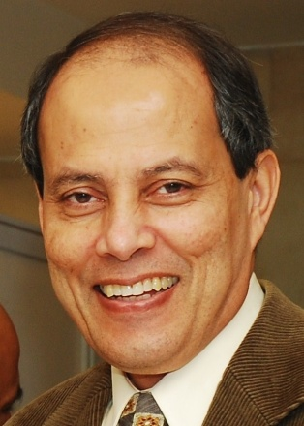***Dr. Saifur Rahman****, Chair, AC-ISE*

Editor-in-Chief, IEEE Transactions on Sustainable Energy

Joseph R. Loring Professor

Director, Virginia Tech Advanced Research Institute

Arlington, VA

AC-ISE Term: October 1, 2007 – September 30, 2013

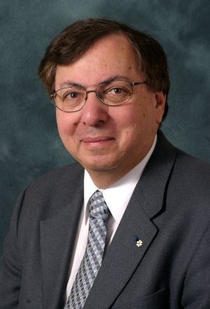***Dr. Howard Alper***

Chair / Président Science, Technology and Innovation Council /

Conseil des sciences, de la technologie et de l'innovation

Ottawa, Canada

AC-ISE Term: **January 1, 2010 - December 31, 2012**

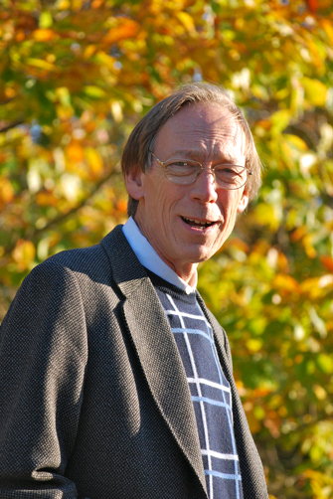***Dr. Peter Arzberger***

Director, National Biomedical Computation Resource

Chair, PRAGMA Steering Committee

University of California, San Diego   
La Jolla, CA

AC-ISE Term: January 1, 2012 - December 31, 2014

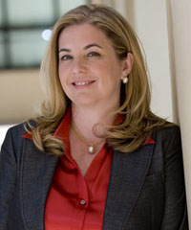***Dr. Vicki Colvin***

Vice Provost for Research

Kenneth S. Pitzer-Schlumberger Professor of Chemistry

Professor of Chemical & Biomolecular Engineering

Rice University

Houston, TX

AC-ISE Term: January 1, 2012 - December 31, 2014

*[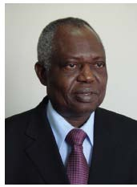](http://au.int/en/dp/hrst/commissioner/biography)****Dr. Jean-Pierre Onvêhoun Ezin***

African Union Commissioner for Human Resources, Science and Technology

African Union Headquarters

Addis Ababa, Ethiopia

AC-ISE Term: **January 1, 2010 - December 31, 2012**

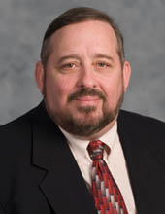***Dr. Mahlon C. Kennicutt II***Professor  
Department of Oceanography  
Texas A&M University

College Station, TX

AC-ISE Term: January 1, 2012 - December 31, 2014

*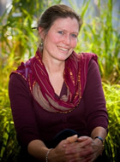****Dr. Susan McCouch***

Professor of Plant Breeding and Genetics and of Plant Biology

Cornell University

Ithaca, NY

AC-ISE Term: January 1, 2012 - December 31, 2014

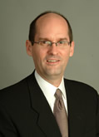

***Dr. Steven W. McLaughlin***

Vice Provost for International Initiatives

Steven A. Denning Chair in Global Engagement

Georgia Institute of Technology

Atlanta, GA

AC-ISE Term: January 1, 2012 - December 31, 2014

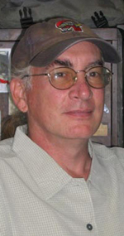***Dr. George Middendorf****, CEOSE Liaison*

Graduate Professor

Department of Biology

Howard University

Washington, DC

AC-ISE Term: April 18, 2011 – January **31, 2013 (**CEOSE)

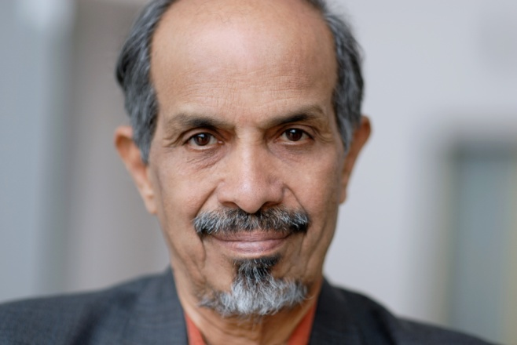***Dr. Roddam Narasimha***

[Engineering Mechanics Unit](http://www.jncasr.ac.in/emu/)

[Jawaharlal Nehru Centre for Advanced Scientific Research](http://www.jncasr.ac.in/)

Bangalore, India

AC-ISE Term: **January 1, 2010 - December 31, 2012**

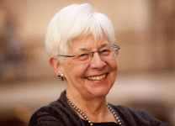***Ms. Jeanne L. Narum***

Founding Director, Project Kaleidoscope (PKAL)

Senior Fellow, PKAL/Association of American Colleges & Universities

Director, The Independent Colleges Office

Washington, DC 20036

AC-ISE Term: January 1, 2010 – December 31, 2012

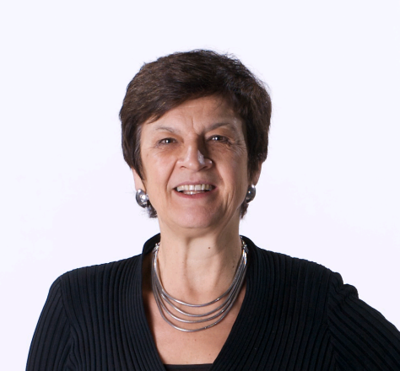***Dr. Maresi Nerad***

Director, Center for Innovation and Research in Graduate Education (CIRGE)   
Professor Extraordinary, University of the Free State, South Africa  
Associate Professor, Educational Leadership and Policy Studies   
College of Education

University of Washington   
Seattle, WA 98195-3600

AC-ISE Term: January 1, 2010 – December 31, 2012

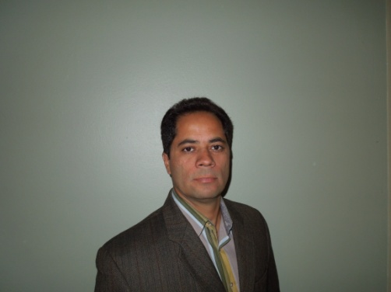***Dr. Efraín O'Neill-Carrillo, PE***

Associate Director, CIVIS: Center for Resources in General Education

Director, Power Quality & Energy Studies Laboratory

Professor, Electrical & Computer Engineering Department

University of Puerto Rico-Mayagüez (UPRM)

Mayaguez, Puerto Rico

AC-ISE Term: January 1, 2012 - December 31, 2014

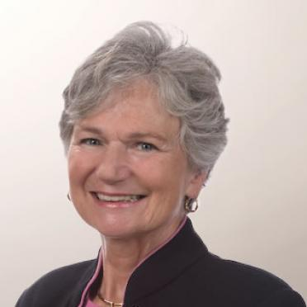***Dr. Anne C Petersen***

President, Global Philanthropy Alliance and

Research Professor, Center for Human Growth and Development

University of Michigan

Ann Arbor, MI 48109

AC-ISE Term: January 1, 2012 - December 31, 2014

**AGENDA**

**NATIONAL SCIENCE FOUNDATION**

**ADVISORY COMMITTEE FOR**

**INTERNATIONAL SCIENCE AND ENGINEERING**

**June 11, 2012**

**Video Conference Meeting**

*Public attendance: Stafford II Room 1155*

**Monday, June 11, 2012**

10:00-10:10 **Approval of minutes of March 19-20, 2012 meeting**

**Expected outcomes from video conference meeting**

*Saifur Rahman, Chair, AC-ISE*

10:10-10:30 **AC-ISE Discussion Paper - Identification of specific follow-on actions initiated/organized by AC-ISE members**

*David Stonner, Deputy Director, OISE*

10:30-11:30 **Discussion of a high-level guiding framework for developing strategies and approaches for identifying opportunities for international collaborations through 2020**

*Saifur Rahman, Moderator*

11:30-11:50 **Next steps and topics for future meetings**

11:50-12:00 **Selection of date for Fall 2012 AC-ISE meeting**

12:00 Adjourn