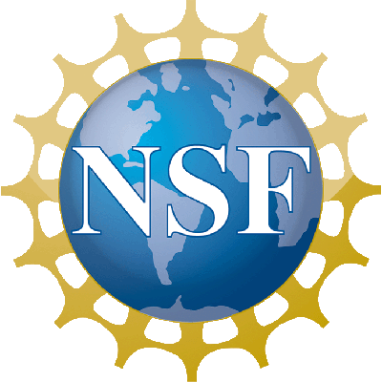

Advisory Committee for the Geosciences
October 14-15, 2009 Meeting
Room 1235
Agenda

Wednesday, October 14

7:30-8:15 AM | Light Refreshments
8:15-8:30 AM | Welcome & Introductory Remarks | Dr. Davis, AC-GEO Chair
8:30-9:30 AM | The State of GEO | Dr. Killeen, AD/GEO & GEO Staff
9:30-11:15 AM | Education & Diversity Subcommittee Meeting (Committee of the Whole) | Dr. Karsten, GEO & Mr. Strang, AC-GEO
11:15-11:30 AM | Break
11:30-2:00 PM | Division Subcommittee Meetings (Working Lunch)  - AGS, Room 1235  - EAR, Room 770  - OCE, Room 730 | Dr. Gombosi, AGS Chair  Dr. Mora, EAR Chair  Dr. Beardsley, OCE Chair
2:00-2:15 PM | Break
2:15-3:15 PM | MREFC Project: Scientific Ocean Drilling Vessel, JOIDES Resolution | Dr. Allan, OCE
3:15-3:30 PM | Break
3:30-4:00 PM | Preparation for Meeting with OD | Dr. Davis, AC-GEO
4:00-5:00 PM | Meeting with Drs. Bement & Marrett | Dr. Davis and AC-GEO Members
5:00-5:15 PM | COV Report: ULAFOS/ATM (now AGS) | Dr. Snow, AC-GEO
5:15 PM | Meeting Adjourned for the Day

Thursday, October 15

8:00-8:30 AM | Light Refreshments
8:30-10:30 AM | Focus Session: International Partnerships & Strategy | Dr. Noonan, AC-GEO
 | GEO International Strategy | Mr. Brown, GEO
 | International Continental Scientific Drilling Program | Dr. Johnson, EAR
 | DIMES: Diapycnal and Isopycnal Mixing in the Southern Ocean | Dr. Itsweire, OCE
 | COSMIC: Constellation Observing System for Meteorology, Ionosphere and Climate | Dr. Fein, AGS
 | Inter-American Institute for Global Change Research | Dr. Filmer, EAR
10:30-10:45 AM | Break
10:45-11:15 AM | NSF Strategic Plan: Status & Schedule | Dr. Cavanaugh, GEO
11:15-11:45 AM | GEO Vision Report | Dr. Davis, AC-GEO
11:45-12:00 PM | Break
12:00-1:30 | Working Lunch
 | COV Report: MGS & Ocean Section/OCE | Dr. Beardsley, AC-GEO
 | Division Subcommittee Reports | Dr. Gombosi (AGS), Dr. Mora (EAR), Dr. Beardsley (OCE)
1:30-2:00 PM | Action Items, Meeting Evaluation, and Wrap-up | Dr. Davis, AC-GEO & Dr. Killeen, GEO
2:00 PM | Meeting Adjourned

