*Approved by AC-ISE on March 14, 2013*

National Science Foundation

Advisory Committee for International Science and Engineering

# **MEETING MINUTES**

# October 25 and 26, 2012

Members Present:

Saifur Rahman, Chair AC-ISE

Peter Arzberger

Vicki Colvin

Jean-Pierre Ezin

Susan McCouch (October 25 only)

George Middendorf, CEOSE Liaison

Roddam Narasimha (by teleconference for morning sessions)

Jeanne L. Narum

Maresi Nerad

Efrain O'Neill-Carrillo

[A list of Advisory Committee Members’ affiliations and dates of service is attached.]

The National Science Foundation Advisory Committee for International Science and Engineering (AC-ISE) met at the Hilton Arlington Hotel, next door to NSF, on October 25 and 26, 2012. The public was welcome to observe the proceedings. The meeting agenda is attached; headings in the following minutes reflect agenda items.

**Thursday October 25, 2012**

Welcome, Review of Meeting Agenda and Objectives, Approval of Minutes, and Housekeeping

Dr. **David Stonner**, Deputy Director, Office of International and Integrative Activities, welcomed AC-ISE members, NSF staff and the public. He noted that the following AC-ISE members were not able to attend the meeting: Howard Alper, Mahlon Kennicutt, Steven McLaughlin, and Anne Petersen. Roddam Narasimha joined the meeting by teleconference during the two morning sessions.

Dr. **Saifur Rahman**, Chair, AC-ISE, invited comments on the AC-ISE video-meeting held on June 11, 2012. Member commented that video-meetings are an efficient opportunity to continue momentum from face-meetings (also possibly through subgroup arrangements), and to reduce costs and time commitments. Video-meetings require focused goals and clear communications. However, face-meetings have advantage of being easier to follow implicit direction of meeting through body language and informal interactions, and are important for meeting colleagues and developing constructive rapport. Members felt that at least one meeting each year should be a face-meeting, especially the first meeting with new members.

The minutes of the June 11, 2012 video-meeting were approved by members.

International Activities across NSF and Beyond

Dr. Stonner announced that the Office of International Science and Engineering (OISE) would be realigned with the Office of Integrative Activities (OIA). He characterized the OISE and OIA realignment as facilitating the cross-foundation, innovative, and incubator features of both offices. Two other NSF offices will be similarly realigned: Office of Polar Programs with the Directorate for Geosciences, and the Office of Cyberinfrastructure with the Directorate for Computer and Information Science and Engineering.

Dr. Stonner presented several data slides illustrating the relative position of the U.S. in the expanding global S&E enterprise. These data emphasize the importance of fostering a variety of international engagements involving U.S. researchers and educators. He summarized several models for co-funding with counterpart funding agencies in other countries, including proposal solicitation and review methods, funding options, and examples of NSF’s collaborative programmatic activities with external partners. He listed NSF proposal calls with explicit international dimensions from each NSF directorate and office to show that international activities permeate the Foundation. Several NSF programs directly encourage the development of an internationally engaged workforce.

The NSF hosted a Global Summit on Merit Review in May 2012 involving heads of science funding agencies from around the world. One outcome of the meeting was the establishment of a Global Research Council (GRC). The GRC will meet in Berlin on May 27-29, 2013 and will focus on principles of research integrity and open access to data and publications. In preparations for the Berlin Summit, regional workshops will be held in five global locations to generate principles for discussion.

Dr. Stonner described several NSF programs that encourage the development of an internationally engaged workforce and that have one or more external partners. Three recent approaches requiring leveraged resources and an international context were summarized: Partnerships for Enhanced Engagement in Research (PEER-Science), Science Across Virtual Institutes (SAVI), and Global Venture Fund (GVF). A graduate fellowship opportunity is being developed to increase international collaboration among postdoctoral fellows.

Conversation on Understanding International Activities at NSF

**Paul Morris**, *Staff Associate, OIIA*

Mr. Morris described powerful text mining tools that he and his NSF colleagues have developed to search NSF documents, and their potential use to document international activities at NSF.

The NSF Office of Integrative Activities (OIA) Evaluation Group launched the Document Search engine on www.research.gov in October 2011, in collaboration with the NSF Division of Information Systems. The Document Search engine allows NSF staff to perform powerful, full-text keyword searches of proposals and annual, interim, and final reports. The real benefit of Document Search is its ability to use complex queries to extract important information from the millions of pages of research documents submitted to NSF.

There are over 3 million PDF documents in the NSF archive (Project Summaries , multi-page Project Descriptions, Biographical Sketches, etc.), and growing daily, representing billions of words relating to basic research in science and engineering. These documents provide rich possibilities for text-mining. Mr. Morris built an in-house search engine using an open source (free) text search language called Apache Lucene. The search engine is very fast and can search billions of document is less than a second. It is far more powerful than Google.

The Document Search tool allows NSF staff to:

* Perform powerful, full-text key word searches of proposals and reports (annual, interim and final);
* Search by proposal ID, proposal section, proposal title, year, status, institution, and NSF division/directorate;
* Search by proximity, wildcard and fuzzy text. Staff can build some very clever search strings using a simple syntax;
* Cluster NSF proposals based on the text found in the Proposal’s Project Description or Project Summary;
* Perform an analysis for snippets of highlighted text extracted from a country specific search;
* Analyze Project Description text to show linkages in the proposed research across a program area.

The Committee was impressed with the analytic opportunities and engaged in a lively conversation with Mr. Morris. In summary, the text search and clustering methods could be used to build a picture of the type of international activities funded by NSF. However, this will require precise questions, adequate resources, and clear priorities.

Member Presentations on Innovative International Activities at Institutions and Societies

**Saifur Rahman**, *Moderator*

Dr. Rahman described a recent professional society meeting where plagiarism among international researchers was identified as a big problem, in large part due to cultural differences and language constraints. Dr. Stonner noted the Global Research Council will address open access of data and research integrity in their meeting in Berlin and that AAAS recently released a relevant document on the issue.

Dr. John Tsapogas, NSF, summarized two program evaluations supported by OISE: East Asia and Pacific Summer Institutes (EAPSI), and International Research Fellowship Program (IRFP). One notable outcome of the evaluations is that IRFP will be changed from an OISE-managed program to a co-funding opportunity involving close interaction with NSF disciplinary offices. OISE is in the process of planning for an assessment of the three NSF Overseas Offices: Europe (Paris), East Asia and Pacific (Tokyo), and China (Beijing).

Members inquired about how international engagements could be made more appealing to minority students. Two members replied that, from their experience, minority students often are more motivated by potential personal interactions among a common diaspora, than by traditional laboratory settings. This has implications for a more developmental component or service orientation for international engagements with minority students.

Dr. Rahman invited each member to give a brief presentation on innovative international activities at institutions and societies. It was soon apparent that there was far more material than members had time to present and meaningfully share during the meeting. Concerns were expressed about the use of this information, especially about the possibility that personal perceptions might be construed as institutional or university-authorized responses. Other concerns included that that list would be incomplete, transitory, and potentially misleading without continuous maintenance. Members were asked to compile their material and submit it to the Executive Secretary following the meeting. The Committee will consider possible organization and uses of the information at a later date.

Dr. DeAndra Beck, NSF, reported that CRDF-Global is establishing a Web-based clearinghouse among international funding agencies to identify opportunities for U.S. researchers to obtain funding from foreign agencies.

Meeting with Wanda Ward

**Wanda Ward,** *Director, Office of International and Integrative Activities*

Dr. Ward summarized the realignment of the Office of International Science and Engineering (OISE) with the Office of Integrative Activities (OIA). She noted that both offices have common interests and objectives, including an incubator role to explore new programmatic options; capacity-building activities to support people, instrumentation, centers, underfunded states; and stewardship responsibilities to address effective policies and practices. All of these activities cut across the Foundation’s disciplinary units and involve innovative approaches to achieving NSF-wide objectives. In addition to embracing an international perspective, the realigned Office of International and Integrative Activities (OIIA) will include an evaluation unit to promote an integrated system of evaluation among directorates. She stressed the importance of in-house evaluations and assessments that are transparent and accessible to the public.

In response to member questions, Dr. Ward stated that the OISE budget will be operationally merged with OIA, but nothing will be taken away, and that staffing will remain the same. The AC-ISE is expected to continue to play an important role in addressing international issues on an NSF-wide basis.

Summary of Afternoon Discussions and Plans for Friday Session

Dr. Stonner reassured the Committee that the budget and international expertise resident in OISE would not be threatened by the realignment. He stated that there is no substitute for a core unit of people who are experts in regional areas, and envisions drawing on untapped expertise throughout NSF in addition to OISE’s existing expertise. Dr. Suresh is an effective spokesman for international engagements and sees it as having a key role among all NSF units. It is important to communicate this to the research community and to the general public.

The meeting recessed at 5:00 p.m.

**Friday October 26, 2012**

Discussion of Measures of International Engagements with members of NSF’s International Coordinating Committee (ICC)

**David Stonner***, Moderator*

The NSF International Coordinating Committee (ICC) comprises representatives from each NSF Directorate to assist OISE in addressing high priority Foundation-wide international issues. Three representatives from ICC discussed international engagements from the perspective of their disciplines: Dr. Robert Wellek, Engineering (ENG), Dr. Jane Silverthorne, Biological Sciences (BIO), and Dr. Suzanne Iacono, Computer & Information Science & Engineering (CISE).

The Committee asked how the realignment would impact the directorates. The ICC representatives agreed that there is a strong relationship between NSF’s disciplinary program staff and OISE, and that would not be affected by the organizational realignment. OISE’s relatively small budget is leveraged by directorates and other funding to the benefit of all participants. Staff details to and from OISE are very useful for sharing institutional knowledge, but there is a trade-off of workload coverage in the “sending” unit.

Directorate staff value travel to make personal connections with international partners, often with OISE assistance. However, they are concerned about recent and anticipated travel restrictions. A member noted a shortage of collaborations with underrepresented regions. ICC representatives responded that sustainable interactions with other countries should be founded on the proposed science and expertise, preferably with a bottoms-up approach. Funding arrangements between NSF and other agencies, such as The Bill and Melinda Gates Foundation and USAID, facilitate partnerships with foreign researchers.

Dr. Wellek, commented that ENG staff and grantees engage in many international activities, some with OISE involvement and some without. He observed that directorates often can react more quickly to opportunities by going alone and avoiding OISE program deadlines. Another ICC member noted that OISE is very nimble in international relations.

It was suggested that each NSF Committee of Visitors (COV) be asked to comment on international activities as a standard part of the COV template.

In response to questions about the role of other advisory committees, Dr. Iacono remarked that the Office of Cyberinfrastructure (OCI) was being realigned with CISE and that it was being recommended that the OCI advisory committee be continued. Advisory committee input is an important source of feedback and new ideas. Others remarked that it is important to explore additional ways in which outside input can be obtained.

Dr. Roddam Narasimha, AC-ISE member, was unable to attend, but called in from India and made several points: (a) the use of publications as metrics for evaluations is problematic and needs attention regarding their impact on research itself; (b) it is important to travel and interact personally with partners, but visas can be difficult and restrictive; (c) shared funding with involvement of international reviewers are useful. He endorsed a second Summit of Heads of Research Councils and encouraged NSF’s continuing leadership.

Considerations for Future Direction and Structure of AC-ISE

David Stonner and Saifur Rahman, *Moderators*

Dr. Stonner invited members to suggest ways to organize and utilize the Committee most effectively. Dr. Rahman asked about the role of the AC and how it could be structured to be a more useful tool for NSF and the international research community.

The Committee was in general agreement on the following matters:

1. Members are committed to serving and helping NSF position itself to address change and opportunities in the global community
2. It is important for the committee to continue to be active and involved during NSF’s organizational realignment.
3. It is useful for the Committee to maintain and strengthen disciplinary expertise and benefit from perspectives of different disciplines involved in international activities. Several options for obtaining disciplinary community input were suggested, including (a) appointing new Committee members from diverse disciplines, (b) interacting and drawing expertise from other NSF advisory committees, and (c) involvement of professional associations. Some members felt that inclusion of non-U.S. members on the Committee would contribute to the Committee’s deliberations. Some members urged NSF to become more active in underrepresented regions (Africa and South America).
4. In some situations, it would be appropriate for the Committee to organize itself into small working groups with targeted topical assignments. Working groups should have a clear charge, objectives, and time-frame.
5. Committee meetings could be organized around a specific theme or topical issues to focus attention and action. Suggestions of topics includes, but were not limited to, metrics, education, public communication, institutional impacts, and trends. Some members wanted more input into developing the meeting agenda.
6. Virtual meetings are good to continue the momentum of committee activities, including possible working groups. However, face-meetings are needed for introducing new members to the Committee.
7. Data mining analyses could be very useful for documenting the extent and character of NSF’s international engagements and support. However, the effort needs to be carefully considered with reasonable questions and adequate resources.

The meeting adjourned at 12:00 noon.

**MEMBER AFFILIATIONS**

**NATIONAL SCIENCE FOUNDATION**

**ADVISORY COMMITTEE FOR**

**INTERNATIONAL SCIENCE AND ENGINEERING (AC-ISE)**

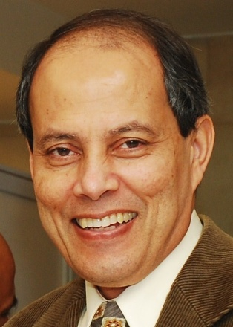***Dr. Saifur Rahman****, Chair, AC-ISE*

Editor-in-Chief, IEEE Transactions on Sustainable Energy

Joseph R. Loring Professor

Director, Virginia Tech Advanced Research Institute

Arlington, VA

AC-ISE Term: October 1, 2007 – September 30, 2013

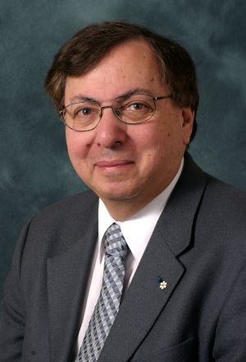***Dr. Howard Alper***

Chair / Président Science, Technology and Innovation Council /

Conseil des sciences, de la technologie et de l'innovation

Ottawa, Canada

AC-ISE Term: **January 1, 2010 - December 31, 2012**

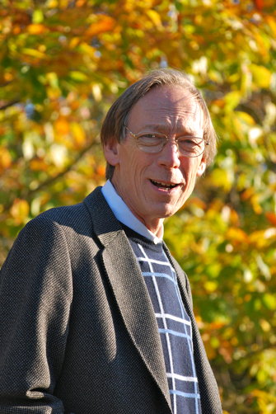***Dr. Peter Arzberger***

Director, National Biomedical Computation Resource

Chair, PRAGMA Steering Committee

University of California, San Diego   
La Jolla, CA

AC-ISE Term: January 1, 2012 - December 31, 2014

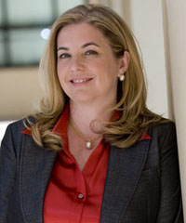***Dr. Vicki Colvin***

Vice Provost for Research

Kenneth S. Pitzer-Schlumberger Professor of Chemistry

Professor of Chemical & Biomolecular Engineering

Rice University

Houston, TX

AC-ISE Term: January 1, 2012 - December 31, 2014

*[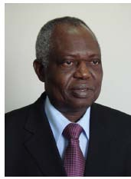](http://au.int/en/dp/hrst/commissioner/biography)****Dr. Jean-Pierre Onvêhoun Ezin***

African Union Commissioner for Human Resources, Science and Technology

African Union Headquarters

Addis Ababa, Ethiopia

AC-ISE Term: **January 1, 2010 - December 31, 2012**

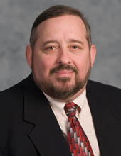***Dr. Mahlon C. Kennicutt II***Professor  
Department of Oceanography  
Texas A&M University

College Station, TX

AC-ISE Term: January 1, 2012 - December 31, 2014

*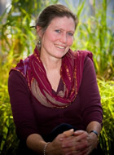****Dr. Susan McCouch***

Professor of Plant Breeding and Genetics and of Plant Biology

Cornell University

Ithaca, NY

AC-ISE Term: January 1, 2012 - December 31, 2014

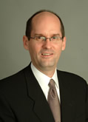

***Dr. Steven W. McLaughlin***

Vice Provost for International Initiatives

Steven A. Denning Chair in Global Engagement

Georgia Institute of Technology

Atlanta, GA

AC-ISE Term: January 1, 2012 - December 31, 2014

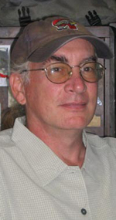***Dr. George Middendorf****, CEOSE Liaison*

Graduate Professor

Department of Biology

Howard University

Washington, DC

AC-ISE Term: April 18, 2011 – January **31, 2013 (**CEOSE)

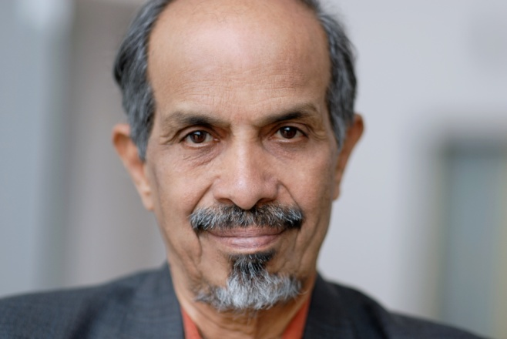***Dr. Roddam Narasimha***

[Engineering Mechanics Unit](http://www.jncasr.ac.in/emu/)

[Jawaharlal Nehru Centre for Advanced Scientific Research](http://www.jncasr.ac.in/)

Bangalore, India

AC-ISE Term: **January 1, 2010 - December 31, 2012**

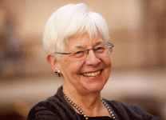***Ms. Jeanne L. Narum***

Founding Director, Project Kaleidoscope (PKAL)

Senior Fellow, PKAL/Association of American Colleges & Universities

Director, The Independent Colleges Office

Washington, DC 20036

AC-ISE Term: January 1, 2010 – December 31, 2012

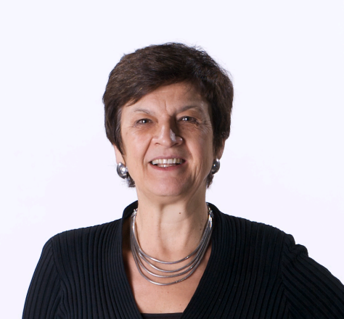***Dr. Maresi Nerad***

Director, Center for Innovation and Research in Graduate Education (CIRGE)   
Professor Extraordinary, University of the Free State, South Africa  
Associate Professor, Educational Leadership and Policy Studies   
College of Education

University of Washington   
Seattle, WA 98195-3600

AC-ISE Term: January 1, 2010 – December 31, 2012

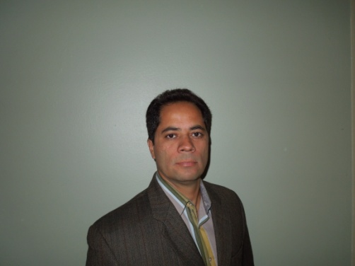***Dr. Efraín O'Neill-Carrillo, PE***

Associate Director, CIVIS: Center for Resources in General Education

Director, Power Quality & Energy Studies Laboratory

Professor, Electrical & Computer Engineering Department

University of Puerto Rico-Mayagüez (UPRM)

Mayaguez, Puerto Rico

AC-ISE Term: January 1, 2012 - December 31, 2014

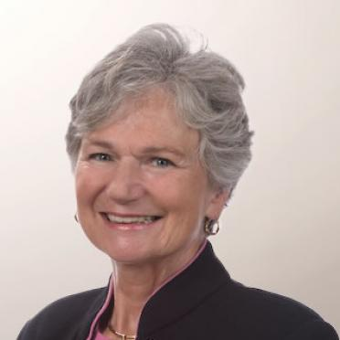***Dr. Anne C Petersen***

President, Global Philanthropy Alliance and

Research Professor, Center for Human Growth and Development

University of Michigan

Ann Arbor, MI 48109

AC-ISE Term: January 1, 2012 - December 31, 2014

***PUBLIC AGENDA***

**NATIONAL SCIENCE FOUNDATION**

**ADVISORY COMMITTEE FOR**

**INTERNATIONAL SCIENCE AND ENGINEERING**

**October 25-26, 2012**

*Meeting will be held in the Arlington Hilton, Masters Ballroom*

**Thursday October 25, 2012**

**8:30-8:45 Welcome, Review of Meeting Agenda and Objectives, Approval of Minutes, and Housekeeping**

*David Stonner, Deputy Director, Office of International and Integrative Activities (OIIA*)

*Saifur Rahman, Chair, Advisory Committee for International Science and Engineering (AC-ISE)*

*Robert Webber*, *Executive Secretary, AC-ISE*

**8:45-10:15 Update on International Activities across NSF and Beyond**

*David Stonner*

10:15-10:30 Break

**10:30-11:45 Conversation on Understanding International Activities at NSF**

*Paul Morris, Staff Associate, OIIA*

12:00-1:30 Lunch

**1:30-3:00 Member Presentations on Innovative International Activities at Institutions and Societies**

*Saifur Rahman, Moderator*

3:00-3:15 Break

**3:15-4:00 Continuation of Member Presentations and Discussion of International Activities**

**4:00-4:30 Meeting with Wanda Ward**

*Wanda Ward, Director, Office of International and Integrative Activities*

**4:30-5:00 Summary of Afternoon Discussions and Plans for Friday Session**

*Saifur Rahman*

**5:00 Adjourn**

**Friday, October 26, 2012**

8:30-9:00 Light Refreshments

**9:00-10:00 Discussion of Measures of International Engagements with members of NSF’s International Coordinating Committee (ICC)**

*David Stonner, Moderator*

10:00-10:15 Break

**10:15-11:15 Considerations for Future Direction and Structure of AC-ISE**

*David Stonner and Saifur Rahman*

**11:15-12:00 Around the table and Wrap-up**

*Saifur Rahman*

**12:00 Adjourn**